Particle not in v (or u) element or particle jumped over v (or u) element
Elizabeth North, 3/14/14
These errors can occur when there are single-grid-width channels in the hydrodynamic model which appear to be parallel to the grid when grid cells are rectilinear (no curvature). The LTRANS boundary maker creates a boundary but there may not be a v or u element inside the boundary so the particle can be inside the model domain but not within an element, resulting in the errors above.
I took the following steps to manually correct the model by forcing the creation of elements by setting the mask value of nodes to water when elements were being generated. Here are the steps:
1. I ran the model with 100,000 particles distributed evenly throughout the model domain to find to locations where the model was having problems. I ran with ErrorFlag = 3 in LTRANS.data so that particles would stop moving and return an error in the ErrorLog.txt file. The ErrorLog.txt lists the particle numbers. I added code in LTRANS.f90 to print out the x/y location of the particle numbers that were having problems (see ‘!ewn grid’ in code for my additions to LTRANS v.2b):
OPEN(210,FILE='ErrorLog.txt',POSITION='APPEND')
SELECT CASE (ele_err)
CASE(4)
write(210,21) n,ix(3)
CASE(5)
write(210,22) n,ix(3)
CASE(6)
write(210,23) n,ix(3)
write(210,*) par(n,pX),par(n,pY),par(n,pZ) !ewn grid
END SELECT
2. I visualized the locations of the model boundary (xybounds.bln created by LTRANS when BoundaryBLNs = .TRUE. in LTRANS.data) and made files with the following information: v-mask node locations and values (v_mask.csv), the v_element locations (v_elements.bln), and the node numbers of the v_elements (v_element_node_numbers.csv). The .bln files are used to create basemaps in Surfer. The code that created these files is in the section of the hydrodynamic module that is pasted below. Search for the name of the file to see it. See Fig. 1 and 2 to see location of missing elements.
3. I set the mask value to 1 at a node that was part of the missing element, let LTRANS create the elements, then set the mask value back to zero. The node number was read off of the plot created in set #2. The code simply looked like this:
v_mask(124975)=1 !ewn grid
See more in the hydrodynamic module pasted below.
4. Change the number of wet elements in the parameter module so that dimensions of the v and u elements include the new elements:

u_elements = wetU + 2 ! u elements with at least one corner with mask_u=1 !ewn grid
v_elements = wetV + 25 ! v elements with at least one corner with mask_v=1 !ewn grid

This code in the hydrodynamic module helped me make sure they were the same:

write(*,*) 'u_elements', u_elements !ewn grid
write(*,*) 'count with adjusted nodes',count !ewn grid

Note: setting nodes that were land to water to create the elements, and then setting them back to land, will not influence current velocities because u and v velocities are multiplied by the mask values (u_m, v_m) when they are read in so will be set to zero.

Section of Hydrodynamic model that was changed (search for !ewn grid to see changes):
! *************************** CREATE ELEMENTS *****************************

!Store Mask Values to multiply by...
m_r = mask_rho
m_u = mask_u
m_v = mask_v

! ~~~~~~~~~~~~~~~~~~~~~~~~~~~~~~~~~~~~~~~~~~~~~~~~~~~~~~~~~~~~~~~~~~~~~~~~~
! ~ 4B. Prepare Elements (i.e., assign ID numbers to rectangular grids) ~
! ~~~~~~~~~~~~~~~~~~~~~~~~~~~~~~~~~~~~~~~~~~~~~~~~~~~~~~~~~~~~~~~~~~~~~~~~~
write(*,*) 'create elements'

! Convert rho nodes lon/lat to x/y coordinates
do j=1,uj
do i=1,vi
x_rho(i,j) = lon2x(lon_rho(i,j),lat_rho(i,j))
y_rho(i,j) = lat2y(lat_rho(i,j))
enddo
enddo

open(1122,FILE='u_mask.csv',STATUS='REPLACE') !ewn grid
! Convert u nodes lon/lat to x/y coordinates
do j=1,uj
do i=1,ui
x_u(i,j) = lon2x(lon_u(i,j),lat_u(i,j))
y_u(i,j) = lat2y(lat_u(i,j))
write(1122,*) x_u(i,j),',',y_u(i,j),',',mask_u(i,j) !ewn grid
enddo
enddo
close(1122) !ewn grid

open(1112,FILE='v_mask.csv',STATUS='REPLACE') !ewn grid
! Convert v nodes lon/lat to x/y coordinates
do j=1,vj
do i=1,vi
x_v(i,j) = lon2x(lon_v(i,j),lat_v(i,j))
y_v(i,j) = lat2y(lat_v(i,j))
write(1112,*) x_v(i,j),',',y_v(i,j),',',mask_v(i,j) !ewn grid
enddo
enddo
close(1112) !ewn grid

! Assign mask values to rho nodes
count = 0
do j=1,uj
do i=1,vi
count = count + 1 !move to next node number
!cycles through each variable replacing the vi,uj part with count
! essentially giving it node numbers
rho_mask(count) = mask_rho(i,j)
rho_angle(count) = angle(i,j)
enddo
enddo

open(1123,FILE='u_node_numbers.csv',STATUS='REPLACE') !ewn grid
! Assign mask values to u nodes
count = 0
do j=1,uj
do i=1,ui
count = count + 1 !move to next node number
!cycles through each variable replacing the vi,uj part with count
! essentially giving it node numbers
u_mask(count) = mask_u(i,j)
write(1123,*) x_u(i,j),',',y_u(i,j),',',count,',',u_mask(count) !ewn grid
enddo
enddo
close(1123) !ewn grid

open(1113,FILE='v_node_numbers.csv',STATUS='REPLACE') !ewn grid
! Assign mask values to v nodes
count = 0
do j=1,vj
do i=1,vi
count = count + 1 !move to next node number
!cycles through each variable replacing the vi,uj part with count
! essentially giving it node numbers
v_mask(count) = mask_v(i,j)
write(1113,*) x_v(i,j),',',y_v(i,j),',',count,',',v_mask(count) !ewn grid
enddo
enddo
close(1113) !ewn grid

! Create matrix that contains the node numbers for each rho element
count = 0
do j=1,uj-1 !z2v3.2
do i=1,vi-1
count = count + 1
r_ele(1,count) = i + (j-1)*vi
r_ele(2,count) = i + 1 + (j-1)*vi
r_ele(3,count) = i + 1 + j*vi
r_ele(4,count) = i + j*vi
enddo
enddo

! Create matrix that contains the node numbers for each u element
count = 0
do j=1,uj-1 !z2v3.2
do i=1,ui-1
count = count + 1
u_ele(1,count) = i + (j-1)*ui
u_ele(2,count) = i + 1 + (j-1)*ui
u_ele(3,count) = i + 1 + j*ui
u_ele(4,count) = i + j*ui
enddo
enddo

! Create matrix that contains the node numbers for each v element
count = 0
do j=1,vj-1 !z2v3.2
do i=1,vi-1
count = count + 1
v_ele(1,count) = i + (j-1)*vi
v_ele(2,count) = i + 1 + (j-1)*vi
v_ele(3,count) = i + 1 + j*vi
v_ele(4,count) = i + j*vi
enddo
enddo

! Create matrix that contains only the rho elements that contain a node
! whose mask value = 1 (i.e., it has at least one water point).
count = 0
do i=1,max_rho_elements
inele = 0
!using the mask determine if any of the nodes for the current
! element are inbounds, if so set inele to 1
if( rho_mask(r_ele(1,i)) .EQ. 1) inele=1
if( rho_mask(r_ele(2,i)) .EQ. 1) inele=1
if( rho_mask(r_ele(3,i)) .EQ. 1) inele=1
if( rho_mask(r_ele(4,i)) .EQ. 1) inele=1 !z2v3.2
!if inele = 1 then at least one of the three nodes for this element
! are in bounds.
if( inele .EQ. 1 ) then
count = count + 1
!create array of elements that contain at least one node in bounds
RE(1,count) = r_ele(1,i)
RE(2,count) = r_ele(2,i)
RE(3,count) = r_ele(3,i)
RE(4,count) = r_ele(4,i) !z2v3.2
endif
enddo

u_mask(40750)=1 !ewn grid
! Create matrix that contains only the u elements that contain a node
! whose mask value = 1 (i.e., it has at least one water point).
count = 0
do i=1,max_u_elements
inele = 0
!using the mask determine if any of the nodes for the current
! element are inbounds, if so set inele to 1
if( u_mask(u_ele(1,i)) .EQ. 1) inele=1
if( u_mask(u_ele(2,i)) .EQ. 1) inele=1
if( u_mask(u_ele(3,i)) .EQ. 1) inele=1
if( u_mask(u_ele(4,i)) .EQ. 1) inele=1 !z2v3.2
!if inele = 1 then at least one of the three nodes for this element
! are in bounds.
if( inele .EQ. 1 ) then
count = count + 1
!create array of elements that contain at least one node in bounds
UE(1,count) = u_ele(1,i)
UE(2,count) = u_ele(2,i)
UE(3,count) = u_ele(3,i)
UE(4,count) = u_ele(4,i) !z2v3.2
endif
enddo
write(*,*) 'u_elements', u_elements !ewn grid
write(*,*) 'count with adjusted nodes',count !ewn grid
u_mask(40750)=0 !ewn grid

v_mask(124975)=1 !ewn grid
v_mask(14823)=1 !ewn grid
v_mask(23861)=1 !ewn grid
v_mask(23864)=1 !ewn grid
v_mask(61075)=1 !ewn grid
v_mask(64966)=1 !ewn grid
v_mask(98039)=1 !ewn grid
v_mask(98040)=1 !ewn grid
v_mask(98041)=1 !ewn grid
v_mask(98042)=1 !ewn grid
v_mask(98046)=1 !ewn grid
v_mask(108558)=1 !ewn grid
v_mask(129954)=1 !ewn grid
v_mask(129454)=1 !ewn grid
v_mask(45484)=1 !ewn grid
! Create matrix that contains only the v elements that contain a node
! whose mask value = 1 (i.e., it has at least one water point).
count = 0
do i=1,max_v_elements
inele = 0
!using the mask determine if any of the nodes for the current
! element are inbounds, if so set inele to 1
if( v_mask(v_ele(1,i)) .EQ. 1) inele=1
if( v_mask(v_ele(2,i)) .EQ. 1) inele=1
if( v_mask(v_ele(3,i)) .EQ. 1) inele=1
if( v_mask(v_ele(4,i)) .EQ. 1) inele=1 !z2v3.2
!if inele = 1 then at least one of the three nodes for this element
! are in bounds.
if( inele .EQ. 1 ) then
count = count + 1
!create array of elements that contain at least one node in bounds
VE(1,count) = v_ele(1,i)
VE(2,count) = v_ele(2,i)
VE(3,count) = v_ele(3,i)
VE(4,count) = v_ele(4,i) !z2v3.2
endif
enddo
write(*,*) 'v_elements', v_elements !ewn grid
write(*,*) 'count with adjusted nodes',count !ewn grid
v_mask(124975)=0 !ewn grid
v_mask(14823)=0 !ewn grid
v_mask(23861)=0 !ewn grid
v_mask(23864)=0 !ewn grid
v_mask(61075)=0 !ewn grid
v_mask(64966)=0 !ewn grid
v_mask(98039)=0 !ewn grid
v_mask(98040)=0 !ewn grid
v_mask(98041)=0 !ewn grid
v_mask(98042)=0 !ewn grid
v_mask(98046)=0 !ewn grid
v_mask(108558)=0 !ewn grid
v_mask(129954)=0 !ewn grid
v_mask(129454)=0 !ewn grid
v_mask(45484)=0 !ewn grid

! Create matrices of x/y for rho nodes and depth values in rho node number
! format
count = 0
do j=1,uj
do i=1,vi
count = count + 1 !move to next node number
!cycles through each variable replacing the vi,uj part with count
! essentially giving it node numbers
rx(count) = x_rho(i,j)
ry(count) = y_rho(i,j)
depth(count) = romdepth(i,j)
enddo
enddo

! Create matrices of x/y values for u nodes in u node number format
count = 0
do j=1,uj
do i=1,ui
count = count + 1 !move to next node number
!cycles through each variable replacing the ui,uj part with count
! essentially giving it node numbers
ux(count) = x_u(i,j)
uy(count) = y_u(i,j)
enddo
enddo

! Create matrices of x/y values for v nodes in v node number format
count = 0
do j=1,vj
do i=1,vi
count = count + 1 !move to next node number
!cycles through each variable replacing the vi,vj part with count
! essentially giving it node numbers
vx(count) = x_v(i,j)
vy(count) = y_v(i,j)
enddo
enddo

! Create matrices of x/y node values for each rho, u, and v element
do j=1,rho_elements
do i=1,4 !z2v3.3
r_ele_x(i,j) = rx(RE(i,j))
r_ele_y(i,j) = ry(RE(i,j))
enddo
enddo

! do j=1,u_elements
! do i=1,4 !z2v3.3
! u_ele_x(i,j) = ux(UE(i,j))
! u_ele_y(i,j) = uy(UE(i,j))
! enddo
! enddo

open(2223,FILE='u_elements.bln',STATUS='REPLACE') !ewn grid 3/5/14
4443 format(I2,',',I2) !ewn grid
do j=1,u_elements
write(2223,4443) 5,0 !ewn grid
do i=1,4
u_ele_x(i,j) = ux(UE(i,j))
u_ele_y(i,j) = uy(UE(i,j))
write(2223,*) u_ele_x(i,j), u_ele_y(i,j) !ewn grid
if(i.EQ.4) write(2223,*) u_ele_x(1,j), u_ele_y(1,j) !ewn grid
enddo
enddo
close(2223) !ewn grid

! do j=1,v_elements
! do i=1,4 !z2v3.3
! v_ele_x(i,j) = vx(VE(i,j))
! v_ele_y(i,j) = vy(VE(i,j))
! enddo
! enddo

open(2222,FILE='v_elements.bln',STATUS='REPLACE') !ewn grid 3/5/14
4444 format(I2,',',I2) !ewn grid
do j=1,v_elements
write(2222,4444) 5,0 !ewn grid
do i=1,4
v_ele_x(i,j) = vx(VE(i,j))
v_ele_y(i,j) = vy(VE(i,j))
write(2222,*) v_ele_x(i,j), v_ele_y(i,j) !ewn grid
if(i.EQ.4) write(2222,*) v_ele_x(1,j), v_ele_y(1,j) !ewn grid
enddo
enddo
close(2222) !ewn grid

! ************************ FIND ADJACENT ELEMENTS *************************

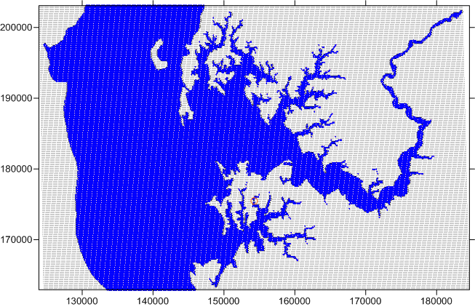
Fig. 1. Missing u-element location (orange circle) in ChopROMS domain.

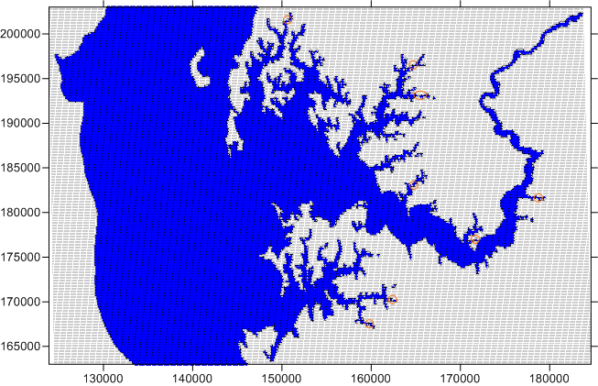
Fig. 2. Missing v-element locations (orange circles) in ChopROMS domain.

